Problem Statement - The Dragons of Kir

created by

Eric Guilford

Ian Hallam

Devon Timaeus

Contents

Executive Summary 3

High Level Problem Summary 3

Elevator Statement 3

Primary Success Criteria 3

Scope 3

Within Project Scope: 3

Outside Project Scope: 3

Detailed Problem Statement 4

Function 4

Form 4

Availability 4

Usability 4

Safety 4

Maintainability 4

Economy 5

Business Context 5

Customer Organization Constraints 5

Development Organization Constraints 5

Key Risks and Uncertainty 5

Timeline 6

Time 7

Historical Context 7

Current Context 7

Future Context 7

Key Stakeholders 7

UI Mockups and Turn Structure 8

UML Diagram 10

Code Coverage 11

# Executive Summary

The purpose of this document is to address the issues that the project will be solving. This document is the first approach and interpretation of the problem. Following documents will further describe the problem and its solutions. This document will also discuss the depths of the problem as well as the different facets that will be considered during development.

# High Level Problem Summary

## Elevator Statement

We are creating an implementation of the board game “The Dragons of Kir” in the C# programming language. The primary reason for this is to allow for players to enjoy the game without having to set up the board, or worry about having lost pieces. Additionally, it will allow for people to throw dragons at each other, which is an excellent pastime.

## Primary Success Criteria

The primary goal of this project is to allow for two players to play a complete game of “The Dragons of Kir” on a basic GUI that will display all of the needed information, and work at a reasonably pace. The success of the project is dependent on the completion of this goal by the end of the Spring 2012-13 quarter.

## Scope

To further define the problem, an assessment of which elements of a payroll system will fall into the scope of the project follows:

### Within Project Scope:

Board Setup

Player Turns

Player placing pieces (taking turns)

Dragon Movement

Win/Loss Checking

### Outside Project Scope:

Extra Rules

“Mulligans” (Turn Redos)

Web-Based gameplay

# Detailed Problem Statement

## Function

1. Ability to set up a game from the start
2. Facilitate alternating player turns, and the actions therein
   1. Allow players to view board
   2. Allow players to place pieces
   3. Allow players to end their turn
   4. Allow Players to view their hand
3. Dragons move according to the rules
   1. Dragons wrap around the board
   2. Dragons interact with tiles appropriately
4. Wins and Losses are correctly identified
5. Allow for network-play (Secondary goal)

## Form

### Availability

* Distributed as a C# executable
* Allow for there to be local “accounts” for network and multi play

### Usability

* Fast response times
* Clear board readability
* Easy to use/play
  + Clean, well-made design
  + Useful help text, and error messages

### Safety

* Only game data is sent across network
* Users cannot break their system

### Maintainability

* Software must be self-sufficient and stable

## Economy

The expected value of this project is nothing more than entertainment. The project is meant to be game for people to play, and has no other contributions.

### Business Context

The board game is not meant to directly interact with any sort of group, the game is simply meant to be played, and would only offer a form of entertainment.

### Customer Organization Constraints

Anyone playing the game would need to have a computer, other than that, there are no constraints that would directly affect what the user would be allowed to do outside of the game.

### Development Organization Constraints

The developers will be the members listed in the project team. At this time there are no plans on expanding the team nor future development after initial development is complete. All of the members are located very close to one another, this will help facilitate communication between the team and agile development of the system. The organizational structure is very flat, there is not a particular lead, each member is just responsible for their own work. Finally, the solution does not have a set budget, there are no plans to make any purchases for the project, however if the need arises there are channels which the team can use to acquire what is needed.

### Key Risks and Uncertainty

The largest risk is the short span of time that the development team has to produce a working system. This is coupled with the fact that the team is limited in the amount of time they are able to spend on the project due to other activities that the members are also pursuing. Another risk is the unfamiliarity of the language that the team will be using.

## Timeline

|  |  |
| --- | --- |
| Week 3 | * Board system functions. * Tiles can placed * Dragons exist * War tents exist * Turns exist * Tiles are drawn by players |
| Week 4 | * War Tents get placed on the board * Dragons move forwards * Placing tiles refined |
| Week 5 | * Effects are placed when tiles are placed * Starting implementation of effects for each different tile type * Starting implementation of Tile Effect resolution |
| Week 6 | * All of Impact tiles have effects finished * Continue implementation of Tile Effect resolution * Impact Tiles effect Dragons * Players can win * Start on implementing Proximity Tiles |
| Week 7 | * Proximity tile Effects finished * Proximity and Impact Tiles effect Dragons * Loop handling started * Effects are resolved properly |
| Week 8 | * Dragon Tiles work properly * Effects for all tiles resolved properly * Loop handling refined and finished * Dragons movement and destroying of tiles finished |
| Week 9 | * Playtesting and bugfixing * Polish * Possibly implement other “new” tiles |
| Week 10 | * Prep for release |

## Time

### Historical Context

The game is relatively new, and as such, the only historical context is that made by previous board game implementations on the computer.

### Current Context

Currently, the board game is being sold at certain locations, but relatively few people have played it.

### Future Context

The game may take off in popularity, and this distribution of the game may reach a high demand. Alternatively, the availability of people to try the game may lead to people wanting the play the game more.

# Key Stakeholders

|  |  |
| --- | --- |
| **Name** | **Role** |
| Michael “Buffalo” Hewner | Project Advisor |
| Eric Guilford | Project Team |
| Devon Timaeus | Project Team |
| Ian Hallam | Project Team |
| ... | End Users |

UI Mockups and Turn Structure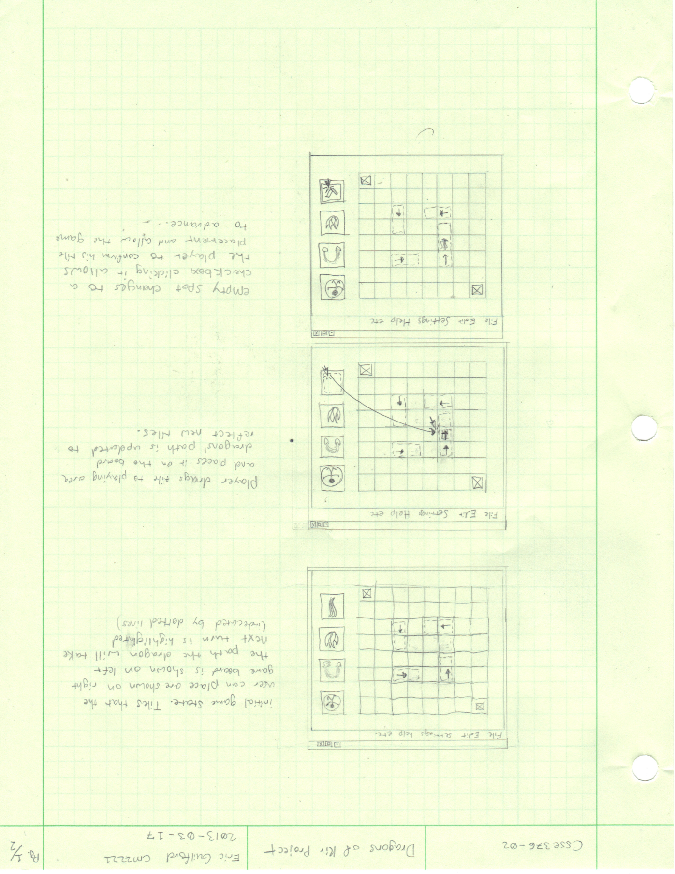

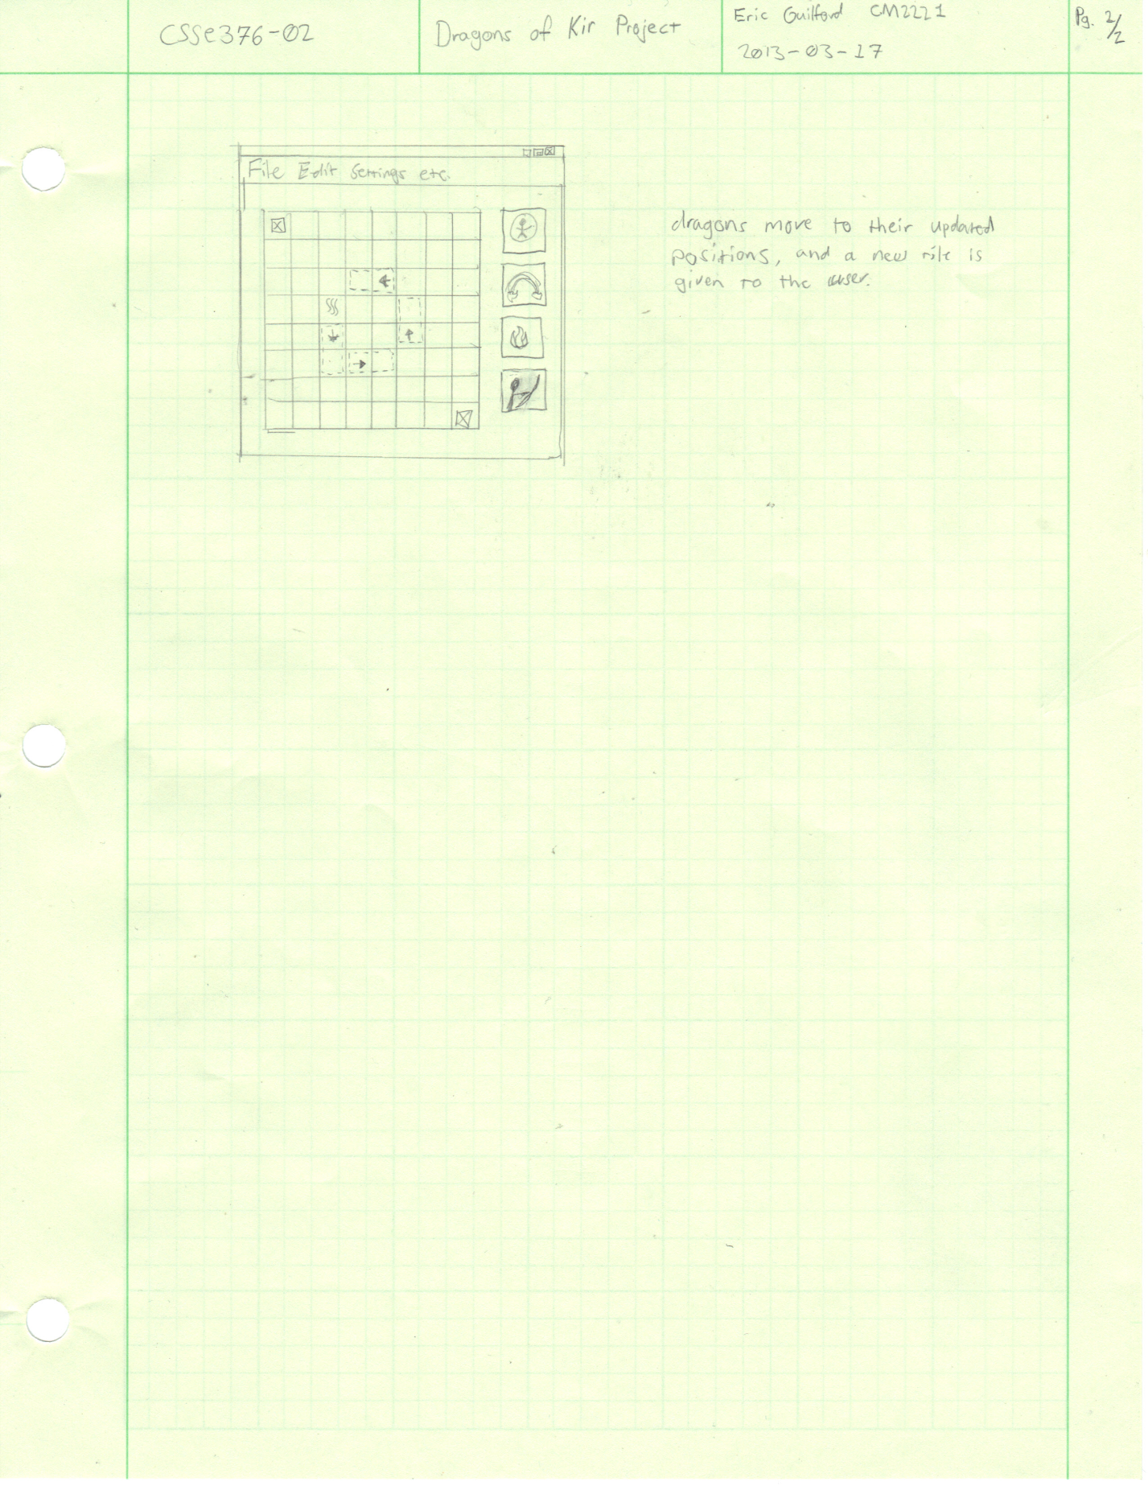

# UML Diagram

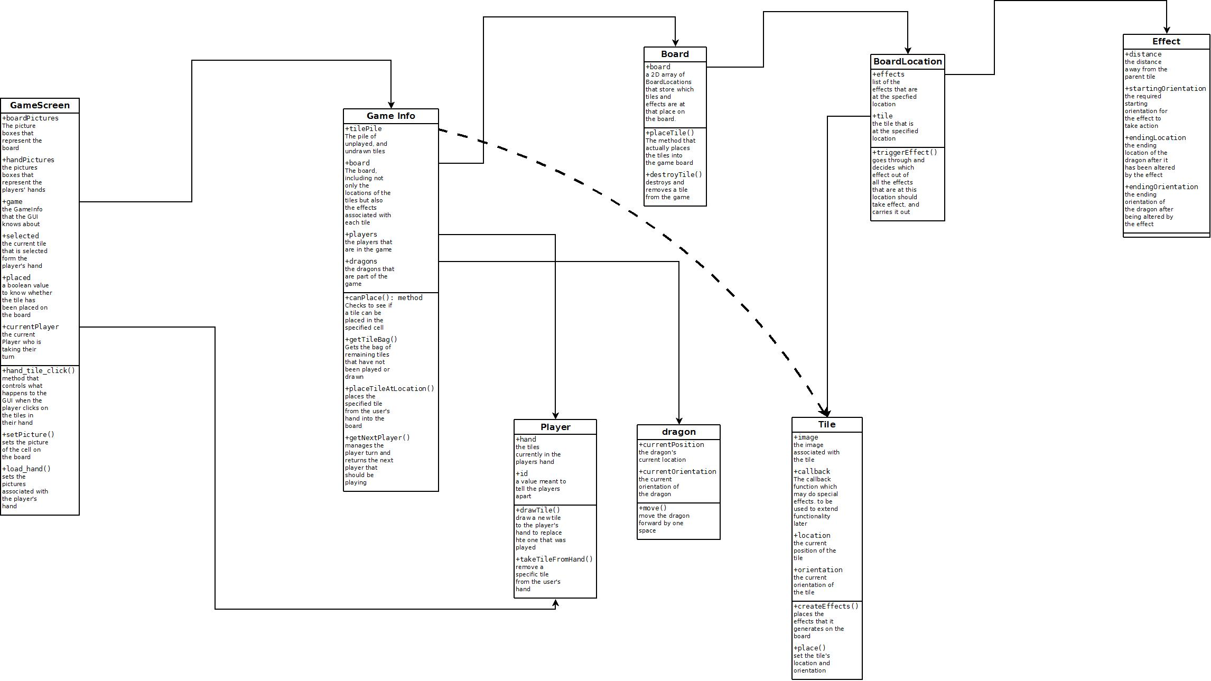

# Code Coverage

For this project, we will use the dotCover coverage tool to record all of our testing coverage, and for general testing of our code. Below is a snapshot of our most recent coverage report.

